

**MEMBERSHIP AND AGREEMENT** (each member)

Lot BAV 025 Beravina / Sabotsy Namehana – Antananarivo Avaradrano 102

|  |  |
| --- | --- |
| **Name:** |  |
| **Postal address:** |  |
| **Telephone :** |  |
| **email:** |  |

1. I really understand that **AINA MADAGASCAR** is simply a link between host families, villagers, escort tour guide, not a professional intermediate nor a Travel agency
2. I really understand all the rules, the concepts of **AINA MADAGASCAR** mentioned in their web site [www.aina-madagasar.org](http://www.aina-madagasar.org) and I accept their conditions
3. I freely commit to their concept of solidarity activities, giving my contribution financially and morally, giving to all the concerned members ( family hosts, villagers, escort tour guide)the adequate amount of money
4. I am informed about the “***Charter of Aina Madagascar”*** and join the membership of **AINA MADAGASCAR**
5. **AINA MADAGASCAR** is informed about my health condition and I own my insurance covering the third party liability, and repatriation
6. I know that the kind of the trip with **AINA MADAGASCAR** is “an outside the box trip”, I will accept that condition and I would not go for **AINA MADAGASCAR** if by any chance things got worse.
7. As a member of **AINA MADAGASCAR** member, I will give my opinion about the progress, the management, of the organization.

|  |  |  |  |
| --- | --- | --- | --- |
|  | **Amount** | **Paid** |  |
| **Administration fees** | **20 €** |  |  |
| **Premium membership** | **10 €** |  |  |
| **Solidarity contribution** | **30 €** |  |  |
| (Free minimum amount) | (Mention if over 30 € ) | |  |
|  |  |  |  |
|  | **Total** |  | **Euros** |

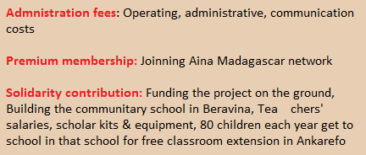

*Please find enclosed the amount of ……………………………..to* AINA MADAGASCAR

I have read all the conditions and I accept

The traveler AINA MADAGASCAR